1．(a). Minimize   
 subject to



(b). Minimize   
 subject to



(d). Minimize   
 subject to



2. We first select  as the basic variable in the first equation, i.e. pivot at the term :



It is easy to see that the system is redundant as the last two equations are identical.

We now delete the last equation, and then pivot at the term  in the second equation, (or in the second equation) obtaining:

 or 

🡺 || 🡺 

And these are the equivalent canonical forms of the original system.

3. (a) Pivoting at the term  in the second equation, gives



which is an equivalent canonical form with basic variable and .

(b) No, because in the above equations, the coefficient of  in the first equation is 0, and hence it is impossible to take  and as basic variables. (In the original system, the coefficients of  and  are both to the 1:-1 ratio in both equations, pivoting at either of them will result in eliminating the other.)

(c) Interpret these results geometrically.

Let



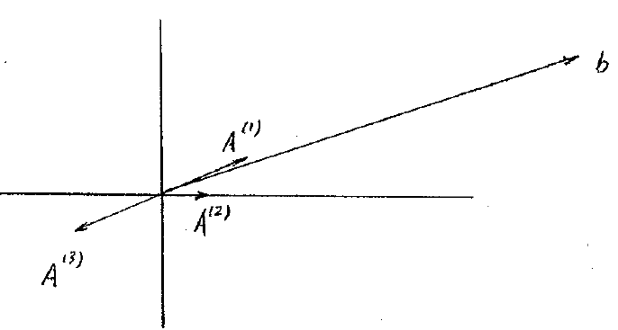

b can be expressed as a linear combination of  and , but NOT a linear combination of  and 

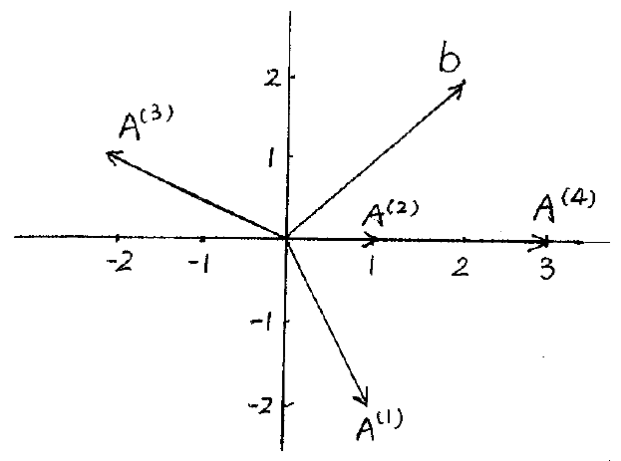4. (a)

Let



We can see that b can be expressed as a linear combination of  & , or of  & ONLY.

(b) Perform pivot operations, we can have the system in the canonical form:

$$-3x_{1}+x_{2} +3x_{4}=6$$

$$-2x_{1} +x_{3} =2$$

When $x_{2}$ and $x_{3}$ are the basic variables. The basic feasible solution is (0,6,2,0)

We can also have the system in the following canonical form:

$$-x_{1}+\frac{2}{3}x_{2} +x_{4}=2$$

$$-2x_{1} +x_{3} =2$$

When $x_{3}$ and $x_{4}$ are the basic variables. The basic feasible solution is (0,0,2,2)

(c) The objective functionfor any. So the objective function is bounded below

(d) Let then 

And let then .

So the minimum value of the objective function is 8.